# Drowsiness Detection System

***Abstract*-** An attempt is made to develop an interface that continuously monitors a driver’s eyes and alerts when the driver is feeling sleepy. An Infrared LED and a Photodiode are used in a combination for proximity and color detection. The IR LED transmits infrared light, that gets reflected by an object, and the reflected light is received by an Infrared receiver (Photo Diode). Amount of light received and reflected differs with distance. This difference causes change in input voltage through IR input. This system when installed in cars and locomotives helps ensure driver/loco pilot alertness thus averting major mishaps.

***Index Terms***- Arduino Nano, IR Sensor, Photo diode, Active Piezoelectric Buzzer, Bread Board.

1. **INTRODUCTION**

T

he research paper consists of a thorough explanation and technical information about the system with emphasis on its role and implementation in daily life.

Officially reported road accidents in India in 2017 stood at 464,910, claiming 147,913 fatalities and 470,975 injured persons, i.e. 405 deaths and 1,290 injuries each day from 1,274 accidents. One of the major causes of traffic accidents is driver drowsiness. Exhaustion plays a significant role here, thus leading to fatal accidents. It has become a serious highway safety problem. If drivers could be alarmed before they become too drowsy to drive safely, some of these crashes could possibly be prevented.

To reliably detect drowsiness, availability of timely warnings is essential. The potency of drowsiness detection methods has been restricted by their inability to consider minute but separate differences. Based on the type of data used, drowsiness detection can be conveniently separated into the two categories of intrusive and non-intrusive methods. During a survey, non-intrusive methods detect drowsiness by measuring driving behavior and sometimes eye features, through which sensors-based detection system is the best method and so are useful for real world driving situations.

1. **TECHNICAL ASPECTS**

Various components used in the system are: -

1. Arduino Nano V3 Board
2. IR Sensor
3. Active Piezoelectric Buzzer Module
4. Mini Bread Board
5. Plastic Safety Glass
6. 9V Battery
7. Jumper Wires

**2.1 Arduino Board**

Arduino is an open-source electronics platform based on easy-to-use hardware and software. Arduino boards are able to read inputs - light on a sensor, a finger on a button, or a Twitter message - and turn it into an output - activating a motor, turning on an LED, publishing something online. You can tell your board what to do by sending a set of instructions to the microcontroller on the board. To do so, you use the Arduino programming language (based on Wiring), and the Arduino Software (IDE), based on Processing.

The Arduino software is easy-to-use, yet flexible enough for advanced applications. It is a multiplatform hardware that runs on Mac, Windows, and Linux.

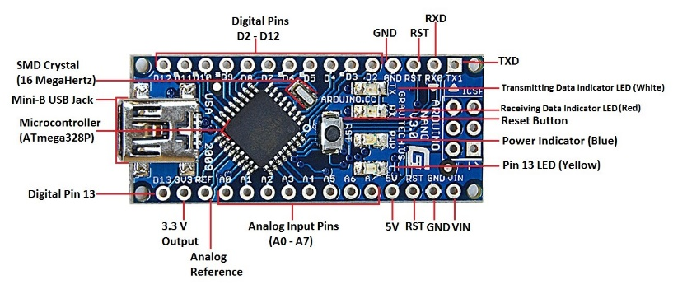

Fig. 1 Arduino Nano Structure

**2.2 Infrared Sensor**

An Infrared sensor (IR) is an instrument that measures and detects infrared radiation in its surrounding environment. It consists of IR LED and IR Photo Diode, together known as Photocoupler. Everything that emits heat (with temperature above 5 K) gives off infrared radiation.

It is a multipurpose sensor which can be used for color detection. The sensor provides a digital as well as analog output. An on-board LED is used to indicate the presence of an object. This digital output can be directly connected to an Arduino, Raspberry Pi or any other microcontroller to read the sensor output. IR sensors are highly susceptible to ambient light and this sensor is suitably covered to reduce the effect of ambient light on the it. The on-board potentiometer should be used to calibrate the sensor.

The emitter is simply an IR LED (Light Emitting Diode) and the detector is simply an IR photodiode. The IR LED looks like a simple LED but emits infrared radiation invisible to the naked eye. The IR photodiode is sensitive to the light emitted by the transmitter. It only detects infrared radiation. The photo-diode’s resistance and output voltage change in proportion to the IR light received. This is the underlying working principle of the IR sensor.

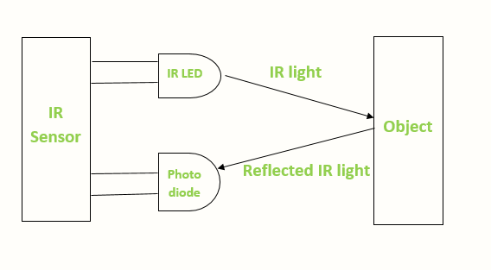

Fig. 2 Working of IR Sensor

There are five basic elements used in a typical infrared detection system:

* Infrared source
* Transmission medium
* Optical component
* Infrared detectors or receivers and
* Signal processing

The system uses Active Infrared Sensors. Active infrared sensors both emit and detect infrared radiation. They have two parts: a light emitting diode and a receiver. When an object comes close to the sensor, the infrared light from the LED reflects off of the object and is detected by the receiver.

**Hardware interfacing of IR Sensor:**

It has 4 pins-

1. VCC +5V

2. Ground

3. D connects with any digital pin of Arduino when IR pair use as Digital Sensor.

4. A connects with analog input pin of Arduino when IR pair use as Analog Sensor.

The sensors have various applications in: Gas detectors, radiation thermometers, night vision devices, moisture analyzer, infrared tracking etc. to name a few.

**2.3 Active Piezoelectric Buzzer**

An active piezoelectric **buzzer**is a small yet efficient component to add sound features to our project/system. It is a compact 2-pin structure hence can be easily used on breadboard, Perf board and on Printed Circuit Boards which makes this a widely used component in most electronic applications.

The 2-pin structure has positive and negative pins assigned with different tasks. The positive pin with a (+) symbol can be connected to either a 3.3V - 5V DC supply and is characterized by a longer terminal. The negative terminal with a (-) symbol is connected to ground of the circuit and is characterized by a shorter terminal.

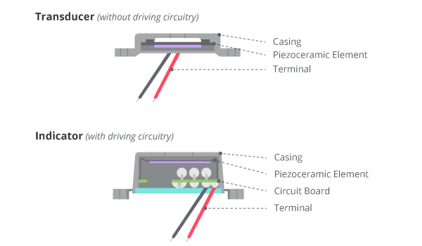

Fig. 3 Active Piezoelectric Buzzer Structure

Arduino Board which is the lifeline of the system is a microcontroller which takes input and gives output according to user settings. Arduino is 100% programmable and very widely used microcontroller used in science projects because of its versatility.

**2.4 Coding**

The system is coded into Arduino programming language which is based on C language.

#define SENSE A0

void setup()

{

pinMode(SENSE, INPUT);

pinMode(6, OUTPUT);

pinMode(LED_BUILTIN, OUTPUT);

}

void loop()

{

## if(digitalRead(SENSE))

## {

## digitalWrite(LED_BUILTIN, LOW);

## pinMode(6, LOW);

## }

## else

## {

## delay (2000);

## if(digitalRead(SENSE))

## {

## digitalWrite(LED_BUILTIN, LOW);

## pinMode(6, LOW);

## }

## else

## digitalWrite(LED_BUILTIN, HIGH);

## pinMode(6, HIGH);

## }

}

## **METHODOLOGY**

The eye blink is a fast closing and reopening of a human eye. Each individual has a little bit different pattern of blinks. The pattern differs in the speed of closing and opening, a degree of squeezing the eye and in a blink duration. The eye blink lasts approximately 100-400 milliseconds.

Hence, we program lines of code that records the amount of time the eyes of a person are closed and compare it against pre-defined period to detect chances of microsleep. If the eyes are closed for a greater amount of time than the specified time period, the buzzer beeps, thus alerting the driver and preventing fatal accidents.

An infrared light emitting diode emits light of Infrared radiation in range 700 nanometers (nm) to 1 mm. This light is not visible by naked eyes but can be seen by a camera (that is why these are also used in night vision cameras). A photo diode gives response in terms of change in resistance when light falls on it. That change is measured in terms of voltage. The IR LED and photodiode are used in a combination for proximity and color detection. An IR LED (transmitter) emits IR light, that light gets reflected by the object, the reflected light is received by an IR receiver (Photo Diode). Amount of reflection and reception varies with the distance. This difference causes to change in input voltage through IR input. This variation in input voltage is used for proximity detection.

When these sensors are attached to the plastic glasses, and adjusted to the eyes of the driver along with all the necessary wiring, the sensor is activated and is ready for deployment. The IR sensor continuously keeps a track on the eyes of the driver and takes reading (which can be seen on the Arduino IDE). Then, the delay or the time period after which the buzzer should ring can be adjusted in the coding portion of the Arduino Nano. Based on these calculations, Arduino then decides whether to alert the driver or not.

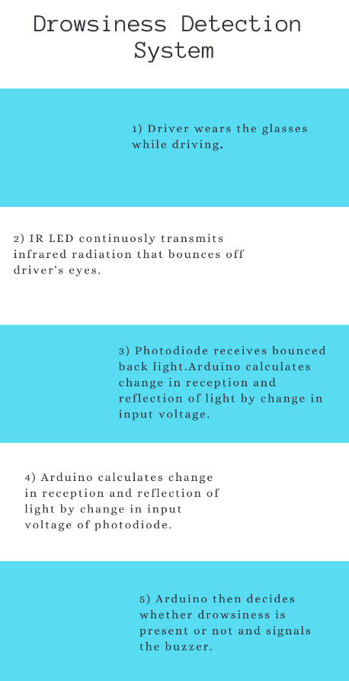

Fig. 4 Flow Diagram

1. **CONCLUSION**

Vehicles currently being manufactured have bare minimum safety features due to cost-cutting measures. These practices can especially prove fatal on the roadside. The Drowsiness Detection System provides a useful solution to the deadly road accidents happening daily around the world. It’s a simple yet cost effective safety feature that manufacturers as well as customers can add to their vehicles to ensure driver and passenger safety.

The estimated cost to build and install it on a vehicle barely touches ₹650 or ~ $9. That’s 2% the cost of an entry level car.

With this price point, it becomes easily affordable to be installed in most of the vehicles today to enhance driver and co-passenger protection and prevent accidents.

A more sophisticated and beneficial system can be built using Ultrasonic sensor instead of IR sensor as infrared waves are susceptible to nature of the light, smoke and dust. This would further enhance total cost of the system.

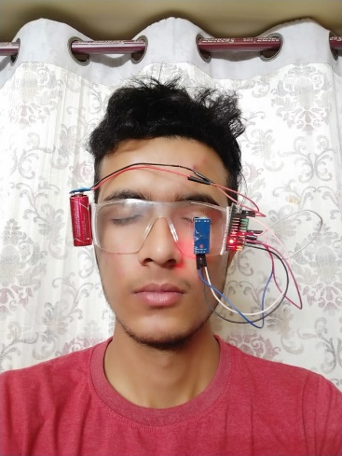 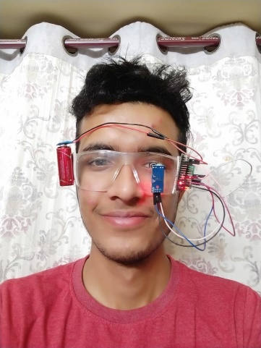

Fig.5 Working model

**References**

# 1. Arduino – Digital and Analog Infrared Sensor

Retrieved from:

<https://roboindia.com/tutorials/digital-analog-ir-pair-arduino/>

2. **IR sensor and working**

Retrieved from:

https://www.researchgate.net/publication/333044694_Bluetooth_Based_Home_Automation_System_Using_Android_and_Arduino

3. **Drowsiness Detection System**

Retrieved from:

https://www.scribd.com/document/276980564/IJCST-V3I4P38-Chisty-Jasmeen-Gill